Graduation Project
BMT 468

Separation of Heart and Respiration signals using MATLAB

Done by:
Maher AL-Hammad 425101064
Sattam AL-Rajih 424100558

Under supervision of:
Dr. Ali Saad

1. Introduction
1.1. Principle of the system
1.2. Electromagnetic Waves
1.3 Cardiac system
1.4 Respiratory system
1.5 Radar Introduction
1.6 Separation of heart beat and breathing
2. Methodology
2.1 Introduction
2.2 Filters theory
2.3 Wavelets methods for separation
3.Results
4. Conclusion
5.References

1. Introduction
1.1. Principle of the system:
Microwave Doppler radar has been used to sense physiologic movement since the early 1970.
Advancing in technology of micro fabrication made it possible to integrate a Doppler radar in a single chip to be compact, lightweight and cheap in the market.
Radar motion sensing systems usually transmit a continuous wave (CW) signal, which is reflected off the target and then demodulated in the receiver. A target with time-varying position reflects the signal and modulates its phase proportional to the target’s time varying position. Therefore, CW radar with the chest as the target will receive a signal similar to the transmitted signal, with its phase modulated by the time-varying chest position. Demodulating the phase will then give a signal directly proportional to the chest position, which contains information about movement due to both heartbeat and respiration. Heart and respiration rates can be extracted from this data figure.1.
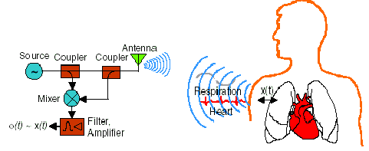

Fig.1 A single antenna system with a single subject. A homodyne radio is used to detect a phase shift proportional to chest displacement due to cardiopulmonary activity.
The peak-to-peak chest motion due to respiration in adults ranges from 4 mm to 12 mm, while the peak-to-peak motion due to the heartbeat is about 0.5 mm. When the wavelength is greater than twice the peak-to-peak motion, the signal can be demodulated by simply multiplying the signal with an un-modulated signal from the same source. When the wavelength is less than twice the peak-to-peak motion, a quadrature receiver is required and more advanced signal processing must be used to accurately demodulate the signal. At 1.6 and 2.4 GHz, the wavelength is 18.75 cm and 12cm respectively, so the wavelength is much greater than the chest motion for measurements made in this device.
1.2. Electromagnetic Waves
Electromagnetic (EM) radiation is: a self-propagating wave in space with electric and magnetic components. These components oscillate at right angles to each other and to the direction of propagation, and are in phase with each other.
Microwaves: are electromagnetic waves with wavelengths shorter than one meter and longer than one millimeter, or frequencies between 300 megahertz and 300 gigahertz.
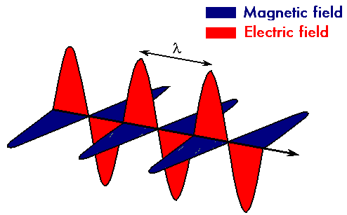
1.3 Cardiac system:
Physiology:
As the heart beats and drives blood into the arteries it moves and its size changes, causing motion of the chest wall that can be detected at the skin surface, both by palpation and with non-contact sensors. The greatest motion occurs at the 4th and 5th intercostals pace when the left ventricle strikes the chest wall as it contacts. The maximum motion detected at the apex with non-contact sensors has an average of 0.6 mm, and this value is expected to vary widely over population due to differences in physiology, health, fitness and age. However, this average motion is sufficient to provide detection with a Doppler radar system.

Measurement:
Clinically, the pulse is examined to establish cardiac rate and rhythm, and the pattern of the palpation can be used for further diagnosis of cardiac and circulatory disease. The normal resting heart rate in adults is 50 to 90 beats per minute. A heart rate outside the normal range can indicate either a cardiac abnormality or another condition that causes abnormal heart rate. An irregular pulse is usually indicative of a cardiac abnormality. The amplitude and contour of the pulse, such as a small, weak pulse, a large bounding pulse, or an irregularly shaped pulse can be indicative of a pathophysiologic state.
1.4 Respiratory system:

Physiology:
For gas exchange to occur in the lungs, air with CO₂ needs to be removed from the lungs and air with O₂ needs to be inspired. In respiration, muscles contract to generate changes in thorax volume, which create pressure differences between the thorax and the external environment, causing air to move in and out of the lungs, from areas of high pressure to areas of low pressure. The motions of the thorax and the abdomen cause significant displacements at the skin surface that are measurable with Doppler radar, allowing non-contact measurement of respiration rates.

Measurement:
Clinically, Most studies indicate 12 to 20 breaths per minute is a normal adult respiratory rate, but some studies indicate that rates as low as 8 breaths per minute are normal. Respiratory rate and volume of respiration together is a strong indicator of respiratory physiology. The respiratory rate is typically measured through observation or palpation of the chest. An accurate reading requires counting for a full minute, because the rates are so low. The measurement of respiratory rate by different examiners can vary significantly.

Conclusion:
Doppler radar simultaneously measures heart and respiration rates. In order to measure the heart rate, it is necessary to use filters to attenuate the respiration signal relative to the heart signal so that the heart signal is dominant. This measurement is non-contact and works through clothing.

1.5 Radar Introduction:
Radar, an acronym for Radio Detection And Ranging, describes a system that transmits an electromagnetic signal and senses the echo from reflecting objects, thereby gaining information about those objects. The time delay between the transmitted and received signals indicates the distance to the target, the frequency shift of the received signal enables calculation of the target’s velocity, and the strength of the signal gives information about the target’s radar cross section, which provides information about its size, geometry, and composition. A major advantage of radio and microwave frequency radar systems is that these waves can penetrate through some objects that light cannot penetrate, allowing detection of objects that cannot be seen. However, radar systems developed for different applications may operate at many different frequencies, varying from a few MHz to optical frequencies. As shown in Figure 2, a radar system typically consists of a transmitter, an antenna, a receiver, and signal processing hardware and/or software.
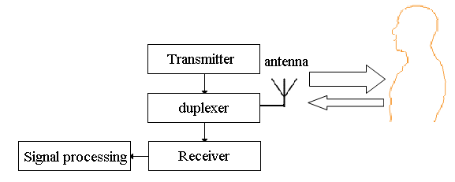
Fig.2: Radar system
1. The transmitter creates waveform and amplifies it to the required transmission power.
2. A directional antenna both concentrates the beam in the direction of the target and enables determination of the direction of the target; electronically tunable antenna arrays are often used for this purpose.
3. The duplexer isolates the receiver from the transmitter while permitting them to share a common antenna.
4. The receiver converts the signal from the transmission frequency to either an intermediate frequency or baseband, separates the signal from both noise and interferers, and amplifies the signal enough for digitization and/or display.
5. Signal processing is used to reject clutter and out-of-band noise, while passing the desired signal, and to derive information from the signal.
Carrier wave is a waveform (usually sinusoidal) that is modulated (modified) with an input signal for the purpose of conveying information. This carrier wave is usually of much higher frequency (green) than the baseband modulating signal (the signal which contains the information) (red). (Wikipedia contributors, 2006a)
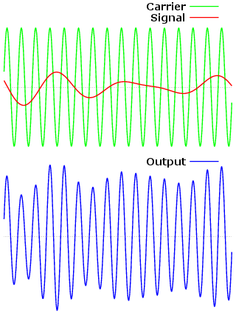
1.6 Separation of heart beat and breathing:
In the Doppler radar cardiopulmonary motion monitoring system, the heartbeat and respiration signals are superimposed on each other. Because the chest moves a much greater distance due to breathing than it does due to the heart beating and a greater area of the chest moves for respiration, the amplitude of the respiration signal is typically about 100 times greater than that of the signal due to the heartbeat. Therefore, the respiration rate can be detected without filtering, but the heart signal must be isolated from the respiration signal to detect heart rate. Once the heart and respiration signals are separated, both need to be processed in order to determine heart and respiration rates, and for optimal accuracy, the stages before the rate determination should add minimal amounts of in-band noise.

with heart rates varying from 43 to 94 beats per minute (1 to 1.67 Hz) and respiration rates varying from 5 to 21 breaths per minute (0.08 to 0.35 Hz).This requires a highpass filter with a transition between 0.70 Hz and 0.35 Hz to isolate the heart signal.

Frequency, wavelength and energy
Waves of the electromagnetic spectrum vary in size, from very long radio waves the size of buildings to very short gamma rays smaller than atom nuclei. Frequency is inversely proportional to wavelength, according to the equation:

v = f λ (1.1)

Where:
v is the speed of the wave (c in a vacuum, or less in other media),
f is the frequency.
λ is the wavelength.

As waves cross boundaries between different media, their speeds change but their frequencies remain constant.
The frequency of the wave is proportional to the magnitude of the particle's energy. Moreover, because photons are emitted and absorbed by charged particles, they act as transporters of energy. The energy per photon is:

E = h f (1.2)
Where:
E is the energy.
h is Planck's constant = 6.626 × 10⁻³⁴ J.s
f is frequency.

2. Methodology:
Why we using MATLAB ? :
MATLAB and Simulink provide DSP algorithm designers, system architects, and embedded hardware and software engineers with a comprehensive set of tools that address the challenges of shortened design cycles for systems with increasing complexity. With MATLAB , you can:
- Develop digital signal processing (DSP) algorithms
- Model and simulate systems
- Verify and validate your hardware and software implementations
2.2 Filters theory:
Band-pass filter: is a device that passes frequencies within a certain range and rejects (attenuates) frequencies outside that range. This filter can be created by combining a low-pass filter with a high-pass filter.
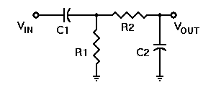
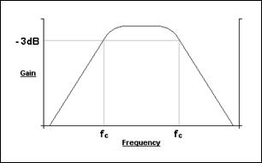

High-pass filter: is a filter that passes high frequencies well, but attenuates (reduces the amplitude of) frequencies lower than the cutoff frequency.
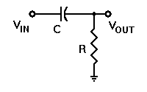
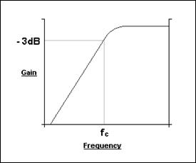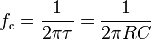

Low-pass filter: is a filter that passes low-frequency signals but attenuates (reduces the amplitude of) signals with frequencies higher than the cutoff frequency.
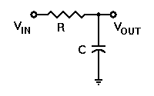
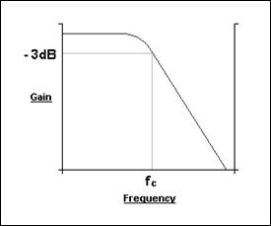

2.3 Wavelets methods for separation:
Daubechies wavelets: are families of orthogonal wavelets defining a discrete wavelet transform and characterized by a maximal number of vanishing moments for some given support. With each wavelet type of this class, there is a scaling function (also called father wavelet) which generates an orthogonal multiresolution analysis.
A biorthogonal wavelet: is a wavelet where the associated wavelet transform is invertible but not necessarily orthogonal. Designing biorthogonal wavelets allows more degrees of freedoms than orthogonal wavelets. One additional degree of freedom is the possibility to construct symmetric wavelet functions.
Wavelets decomposition theory:

Description
The Wavelet packet decomposition extends the discrete wavelet transform in a way that the approximation and details are generated by a tree of lowpass and highpass operations, according to
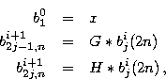
(G : Lowpass, H: Highpass), where denotes a convolution operation.

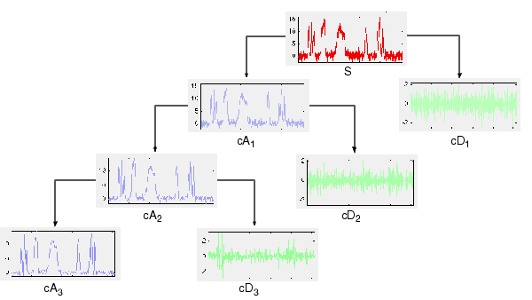
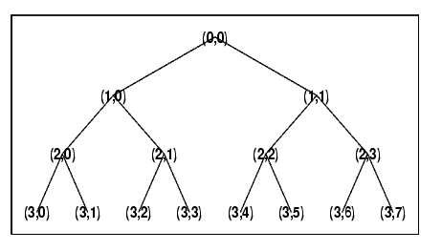
3. Results:
1- Heart signal without respiration:
We have heart signal has been taken from patient without breathing; during the measurement the patient was holding the breath.
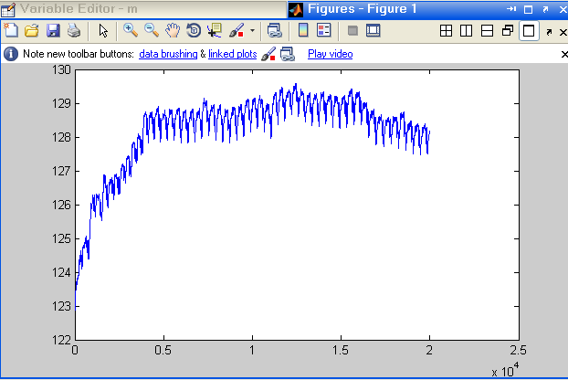
We need to know the heart rate from this signal.
So, the first thing we need to do is to apply this signal on Matlab program.

Then we cut the signal up to 10 second, because it is sufficient for our measurements. Next, we applies data into low pass filter to make it look like Sine wave to determine number of peaks in 10 second which will be the heart rate in 10 second after that we can calculate heart rate in one minute.

Steps to do that
- load c:\p3dbc.prn
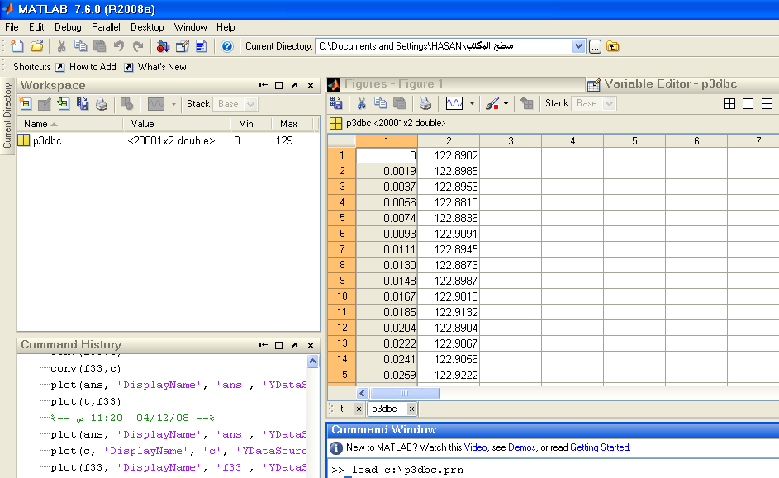

- Then we delete the first column which is the time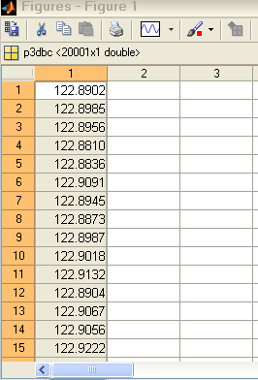
- Save it in text file.
- Name it f3 for example.
- Open it as workspace
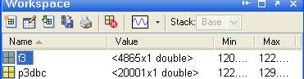

- t=0:10/4864:10
;

- s=t'

- Plot(s,f3)
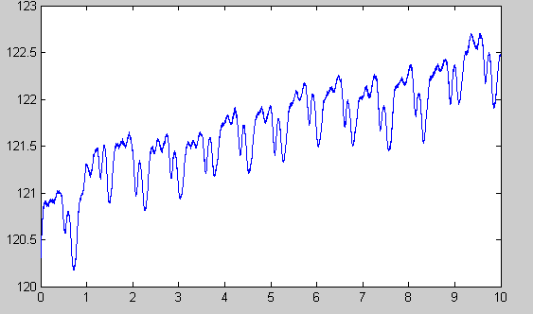

Applied this wave to low and high bass filter to count number of pulses per minute by:

1-Save f3 as .mat file

2-Opining wave menu in Matlab
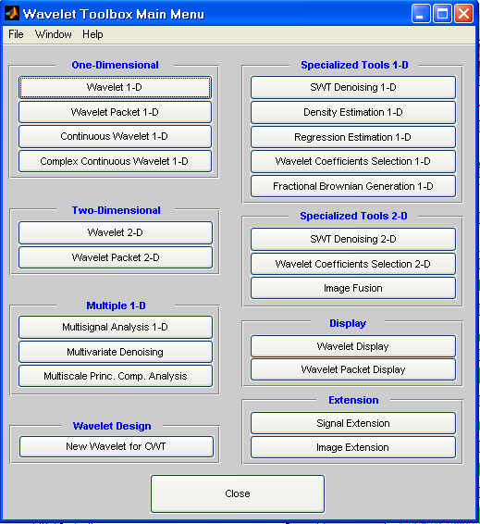
3-Choosing wavelet 1-D
4-Load the signal
5-Choosing db with 10 levels
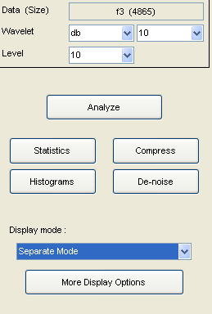
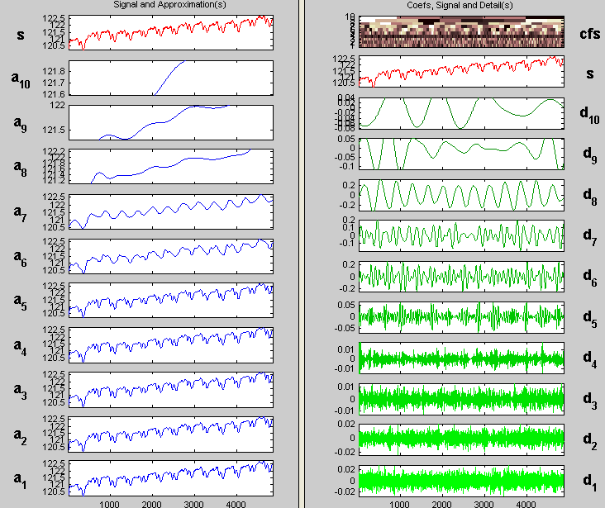

Counting number of peaks in d8
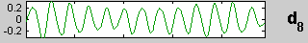
Number of peaks in d8 =heart pulse rate in 10 second=13pulses
Number of pulses in one minute = 13*60/10=78 BPM

2- Heart and respiration signal
Here we take the signal from the patient
And this signal include Heart and respiration signal.
After cutting up the signal to 10 seconds.
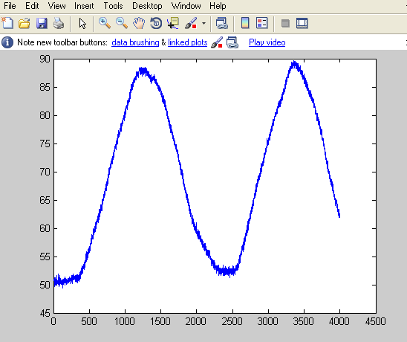

Using db wavelet to separate the two signals 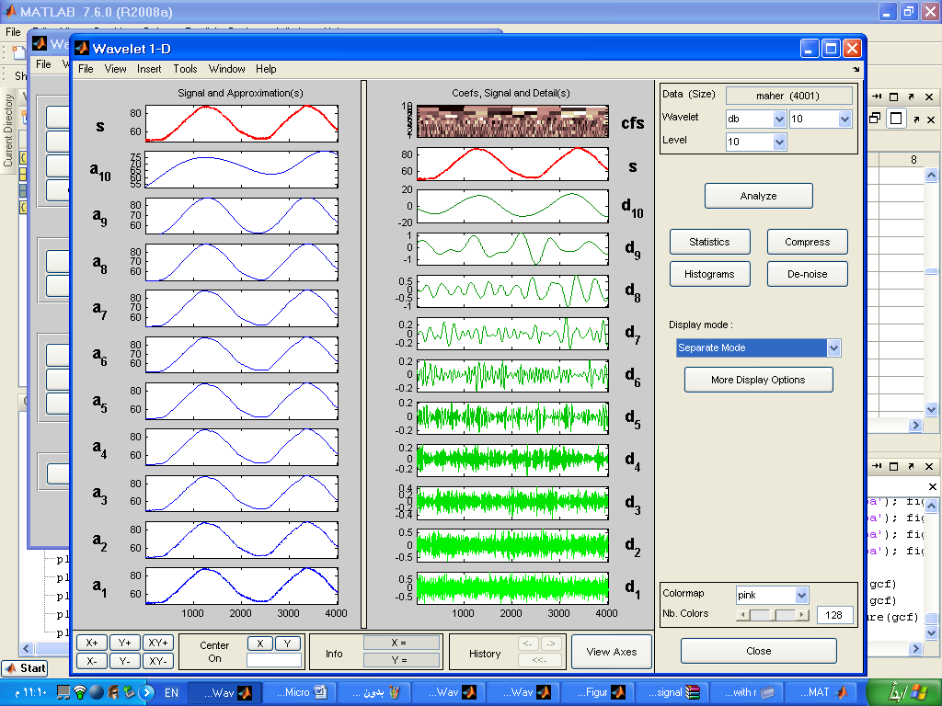

Respiration signal
No. of peaks = 2 in 10 second
In one minute = 60*2/10=12bpm (respiratory rate)

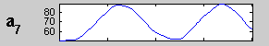

Heart signal
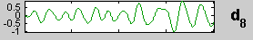
No. of peaks = 11 in 10 second
In one minute = 60*11/10=66bpm (heart rate)

4. Conclusion
This project provided us a good experience in signal processing on real biomedical signals. We also gain some experience in using Matlab signal processing package for this purpose. It also, introduces wavelets decomposition and wavelets techniques for signal processing issues.
After many research in the Internet, we have a good and clear background on the operations that we can do on signals.
We also hope that in the future, we will be among those people who trait such scientific issues.

5. References
-"Signal Processing Methods for Doppler Radar Heart Rate Monitoring" Anders Høst-Madsen1,2, Nicolas Petrochilos2, Olga Boric-Lubecke1,2, Victor M. Lubecke1,2, Byung-Kwon Park2, and Qin Zhou3 Kai Sensors, Inc., HI, USA1, University of Hawaii at Manoa, HI, USA2 and Broadcom, Inc., USA3
-Astronomy Notes http://www.astronomynotes.com/
-"NON-CONTACT MEASUREMENT OF HEART AND RESPIRATION RATES WITH A SINGLE-CHIP MICROWAVE DOPPLER RADAR "Amy Diane Droitcour June 2006
-http://en.wikipedia.org/wiki/Daubechies_wavelet
http://en.wikipedia.org/wiki/Biorthogonal_wavelet-
http://www.ni.com-
http://www.rslab.ru/?lang=english

-"A Digital Signal Processor for Doppler Radar Sensing of Vital Signs "B. Lohman1, O. Boric-Lubecke2,V.M. Lubecke2, P.W. Ong2, M.M. Sondhi2 1ICT Group, Department of Electrical Engineering, Delft University of Technology, The Netherlands 2Bell Laboratories, Lucent Technologies, USA
-Marple SL Jr.(1987) Digital spectral analysis with applications. Prentice Hall, Englewood Cliffs, New Jersey
-"DETECTION OF MULTIPLE HEARTBEATS USING DOPPLER RADAR"
Qin Zhou, Jianhan Liu, Anders Høst-Madsen, Olga Boric-Lubecke, Victor Lubecke
Department of Electrical Engineering, University of Hawaii

